KDØRC

**Flexicraft Utility**

User Manual

Len Koppl, KDØRC

8/9/2024

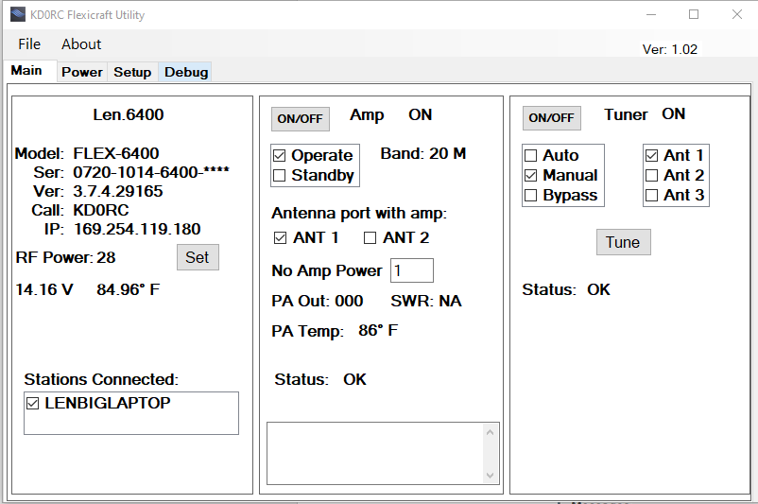

1. Introduction

The KD0RC Flexicraft Utility provides a means for automatically setting Flex drive power to an Elecraft amplifier based on amp status (operate/standby). Because each band and mode can have different drive requirements, the utility is set up to take in ten states for each band. The states are defined by the mode and whether the amp is in operate or standby mode.

There is a setting to tell the utility which antenna port is connected to the amplifier, and what power level to use if the other port is selected.

The utility also provides control for the KPA 500 and KAT 500 allowing control locally or remotely.

1. Setup
2. Go to the GitHub site (<https://github.com/KD0RC/KD0RC_Flexicraft_Utility>).
3. Click on the latest release (right hand side of the GitHub page.
4. Download setup.zip.
5. Unzip (extract all) the files to whatever location you like. Note that every time you do an update, you need to run setup.exe from the same location or it won’t install. (See Troubleshooting section 4.1 if you have issues with this).
6. Run Setup.exe.
7. The utility will install itself and then execute.

The first time the utility is run, it will create the **C:\KD0RC\FlexictaftUtility** directory and place several text-based .ini filesin it. These files will be described in detail later in this document. Note that the application takes care of editing and saving these files, so you should never need to open or edit them manually.

The KPA 500 amplifier should be on and the serial port labeled RS232 (XCVR) should be plugged into one of the USB ports on the Flex radio. The serial port labeled RS232 (PC) should be plugged into the computer where you run the utility. The computer needs to be on the same LAN segment as your Flex radio.

The KAT 500 tuner should be on and the serial port should be plugged into the computer where you run the utility. It needs to be on the same LAN segment as your Flex radio. If you don’t have the KAT 500 tuner, don’t try to do a Tuner connect, the amp control will work without it.

The first time you run the utility, you will be prompted to enter the Amp and Tuner serial port information in the Setup tab. See the Elecraft manuals for setting the data rates. Select the appropriate values and click the connect buttons at the bottom of the screen.

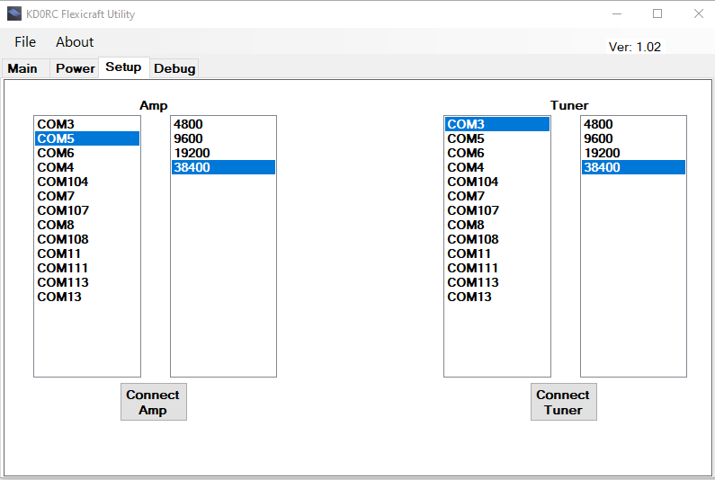

Going forward you should not need to manually do the connect unless something on your system changes or you delete your .ini files.

Setup will create the directory “**C:\KD0RC\FlexicraftUtility**” if it does not already exist. It will create four files if they do not exist:

**Flexicraft_Ant.ini** – Tracks which Flex antenna port has the amp connected.

**Flexicraft_AmpPort.ini** – Tracks the comport and speed of the amplifier.

**Flexicraft_Power.ini** – Grid of power settings by band, amp status (Operate, Standby) and mode.

**Flexicraft_TunerPort.ini** – Tracks the comport and speed of the tuner.

None of these files should be edited with a text editor.

1. Operation

The screen has four tabs

* Main
* Power
* Setup
* Debug

**Main**



The Main tab has three sections; Radio, Amp and Tuner.

**Radio**

The radio panel gives basic information about the radio, and provides a place to set radio RF Power without having to go to the Power tab to type it in manually. The serial number of the radio has its last four digits hidden so that you can post screen shots of it without disclosing the SN of your radio. To see the last four digits, hover the mouse over the asterisks.

The RF Power box shows the RF Power as set in the radio.

The Set button will update the table in the Power tab for the band, mode and amp status (Operate, Standby). As you are operating if you notice that the amp needs a little more or less power to get the desired output, make the adjustment using the SmartSDR or Maestro RF Power slider. When you have it the way you want it, click the Set button and the value will be saved.

If you are in a MultiFlex environment (two stations connected to the radio simultaneously), both stations will show in the Stations Connected box. Check the one that you are running so that you get the results that you expect. If there is only one station connected, it will automatically be selected.

The voltage and temperature reported by the radio are shown and updated in near real-time. You can toggle between Fahrenheit and Celsius by clicking on the temperature.

**Amp**

The Amp tab shows the status of the KPA 500 amplifier as well as providing controls. The ON/OFF button allows you to power the amp on and off. This is especially nice when you are operating remotely. The indicator will be ON, OFF or Offline. Offline means that the serial connection has not been made.

The Operate and Standby checkboxes follow the status of the amp and can be used to change the amp. In other words, you can set the status of the amp by pressing the button on the amp itself, or by clicking the checkboxes on the app.

The Power tab contains the RF Power settings for each band, mode and amp status (Operate, Standby).

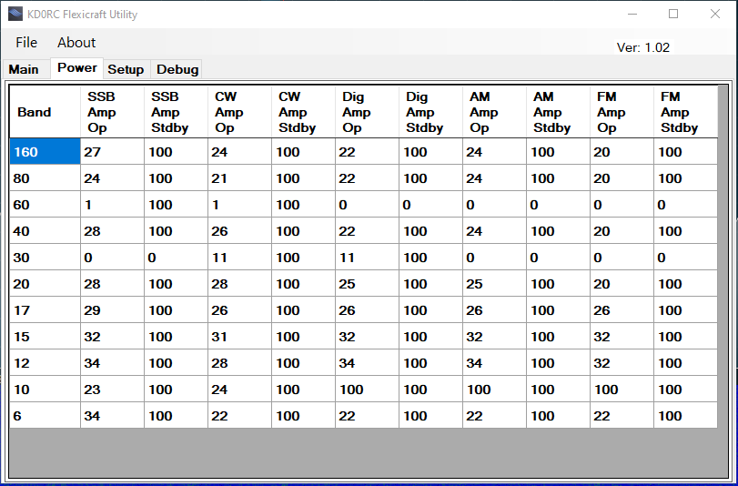

According to the example Power tab (above), if you are on 160 meters and in LSB, your Flex will be set to 27 W if the amp is in in Operate and 100 W if the amp is in Standby. If you are in CW, then it would use 24 W in Operate.

Use the ANT1 and ANT2 checkboxes to select which Flex radio port has the amp attached. If you set your transmit slice to use transmit antenna ANT1 and ANT1 is checked in the app, then the power levels specified in the Power tab will be used as described above. If the transmit slice is then changed to use transmit antenna ANT2, the radio’s RF Power will be set to the value in the No Amp Power box.

PA Out shows the output of the amplifier, and will match the value shown on the amplifier’s display. SWR shows NA when not transmitting, and the SWR reported by the amp when transmitting.

PA Temp is the temperature of the PA in the amp. Click on the value to switch between Fahrenheit and Celsius.

Status shows any amp faults. If there is a fault, radio transmit will be shut off immediately and the fault will display in the Status box with a red background. To clear the fault in the amp and enable transmit in the radio, double-click the status message.

The open box at the bottom of the Amp panel is for messages if the app can’t connect to the amp or tuner.

**Tuner**

The Tuner panel is used to control and provide status for the KAT 500 tuner. The ON/OFF button allows you to power the tuner on and off. This is especially nice when you are operating remotely. The indicator will be ON, OFF or Offline. Offline means that the serial connection has not been made.

The Tune button will put the amp in standby, start the tune function in the radio, then start the tune sequence in the tuner. Once the tuner finds a match, the radio goes back to receive and the amp is returned to the status it had before the tune button was clicked.

Status shows any tuner faults. If there is a fault, it will display in the Status box with a red background. To clear the fault in the tuner, double-click the status message.

**Power**

The Power tab allows you to manually enter the RF Power level that you want the radio to use based on amp status (Operate, Standby), band and mode.

If you manually change any values, be sure to go to File, Save to save them in the Flexicraft_Power.ini file. This is a text file, but do not edit it using a text editor – always use the Power tab to manually edit the file.

**Setup**

The setup tab provides a way to specify comport and speed for the amp and tuner serial ports. Once entered and connected, the values are saved in the Flexicraft_AmpPort.ini and Flexicraft_TunerPort.ini files.

**Debug**

The Debug tab shows various items used while developing the application. If you have problems, Len, KD0RC may ask to see a picture of your Debug tab. Double-click the tab to clear its contents.

1. Troubleshooting
   1. **Install**

Most install issues stem from not running setup.exe from the same location. If you get a message saying that “**You cannot start application Flexicraft Utility from this location because it is already installed from a different location.**”, you have two choices:

1. Extract the setup.zip file to the same location that you used last time and try again.
2. In Windows, go to settings, Apps and uninstall Flexicraft Utility. Note that you do not have to delete any folders, just uninstall the app.